
Yeshwantrao Chavan College of Engineering
Department of Electronics Engineering

Project Title

An Intelligent Emergency Alert And Wireless Tracking System

Presented By Name of Students
1.Mrunali Jibhakate 2. Palak Nikhare
3. Sakshi Raut 4. Gauri Sitre
5. Karan Nehare

Under the Guidance of Name of Guide
Prof. Rupali Balpande

Introduction

An Intelligent Wireless Tracking System is a modern technology designed to monitor, locate, and manage the movement of people, vehicles, or objects in real time using wireless communication and smart data processing. By integrating technologies such as GPS, RFID, IoT sensors, and wireless networks, the system enables accurate tracking without the need for physical connections.

The “intelligent” aspect of the system comes from its ability to analyze collected data, detect patterns, and make automated decisions or alerts. This helps improve efficiency, safety, and security in various applications. Wireless tracking systems are widely used in areas such as logistics and supply chain management, vehicle tracking, healthcare monitoring, asset tracking, and smart city infrastructure.

OBJECTIVE
- To provide real-time tracking and monitoring of people, vehicles, or assets using wireless communication technologies.

- To enhance safety and security by detecting abnormal situations and
generating instant alerts.

- To enable efficient data collection and analysis for intelligent decision- making and system optimization.

- To reduce human effort and operational costs through automation and
wireless monitoring.

- To support quick response in emergency situations by sharing accurate location and status information.

- To improve management and control in applications such as transportation, logistics, healthcare, tourism, and asset tracking.

Block Diagram & Implementation

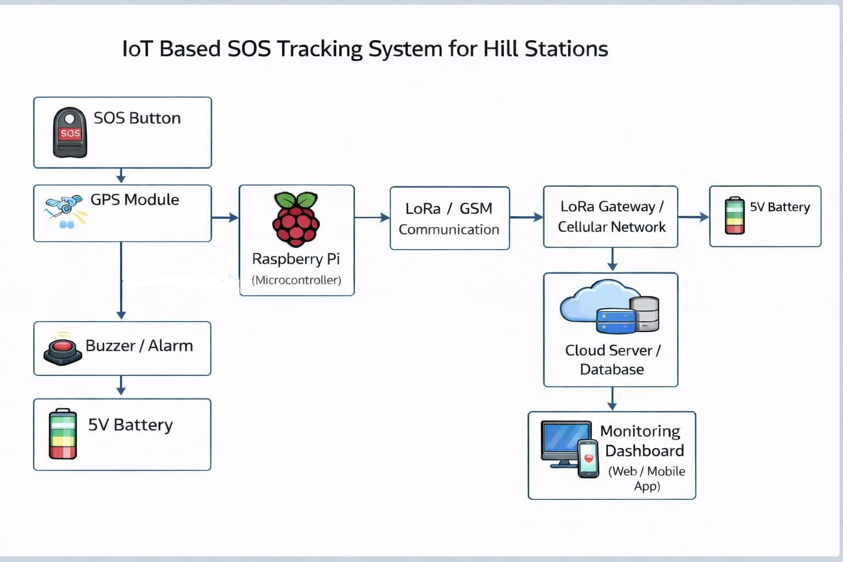

Circuit Diagrams

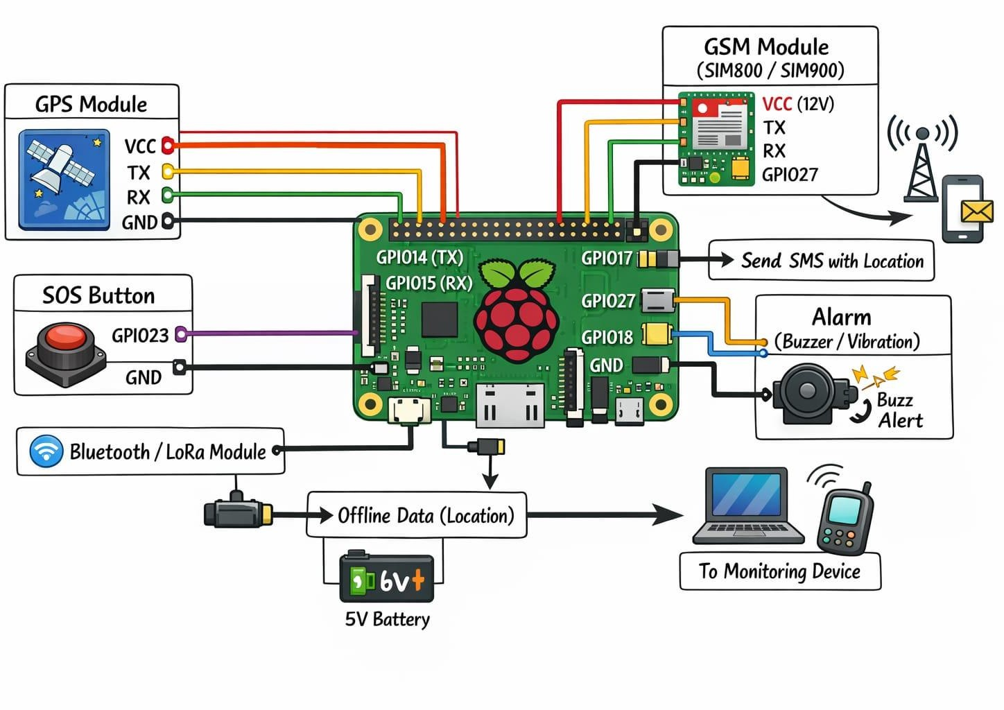

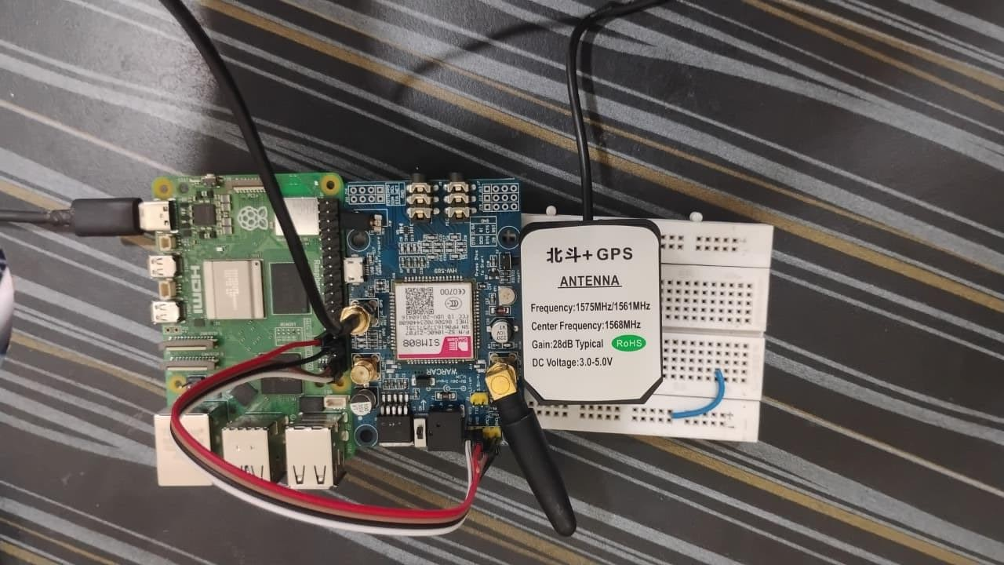

Problem Statement

- Remote and critical areas often lack reliable mobile network connectivity.

- People in such areas cannot easily share their real-time location.

- Existing SOS systems depend heavily on the internet or cellular networks.

- Satellite-based emergency systems are expensive and not widely
accessible.

- Delayed or failed emergency communication increases risk to human life.

Project Scope

  - To design a wireless-based system for real-time location tracking.

  - To provide emergency alert functionality in critical situations.

  - To ensure reliable communication in low or no network areas

  - To support different users such as tourists, workers, or rescue
teams.

  - To allow future integration of new communication technologies.

  - To improve safety and response time in remote environments.

Literature Survey

Sr. No | Title of Paper | Author Name | Year of Publication & journal | Findings
1. | Women Safety System using GPS and GSM | A. B. Patel, N. Shah | 2021 IEEE International Conference on Smart Systems | Developed a GPS and GSM based emergency alert system that sends real-time location through SMS. Improved response time during emergency situations.
2. | IoT Based Smart Emergency Alert System | R. Sharma, P. Verma | 2022 International Journal of Engineering Research & Technology (IJERT) | Proposed an IoT-based emergency alert system with real-time monitoring and instant message alerts using GSM.
3. | Smart Tracking System using GPS and  GSM Technology | S. Kumar, M. Singh | 2020 International Journal of Advanced Research in Electronics and Communication Engineering (IJARECE) | Implemented real-time location tracking and alert system to improve personal safety and monitoring.

Literature Survey

Sr. No | Title of Paper | Author Name | Year of Publication & journal | Findings
4. | Emergency Communication System using LoRa Technology | K. Mehta, A. Joshi | 2023 IEEE International Conference on Wireless Communication | Designed a low-power long-range communication system using LoRa for emergency data transmission in remote areas.
5. | IoT Based Child and Women Safety System | P. Desai, R. Kulkarni | 2022 International Journal of Scientific Research in Engineering and Technology (IJSRET) | Developed an emergency alert system using IoT, GPS and GSM for safety of women and children with real- time alerts.
6. | Smart Wearable Emergency Alert and  Tracking System | M. Khan, S. Ali | 2024 International Journal of Smart Computing and Applications | Proposed a wearable emergency device for continuous location tracking and instant emergency notifications.

Methodology

System Initialization
When the device is powered ON, the Raspberry Pi initializes all connected modules such as GPS, GSM/LoRa, push button, buzzer, and LED.

Location Acquisition
The GPS module continuously receives signals from satellites and
calculates the current latitude and longitude of the user.

Data Processing
The Raspberry Pi reads the GPS data through serial communication
and processes it into a readable format suitable for monitoring.

Normal Monitoring Mode
In normal condition, the system sends the location data to the authorized person at fixed time intervals using the GSM or LoRa communication module.

- Emergency Detection (SOS Mode)
When the SOS push button is pressed, the system immediately switches to emergency mode and triggers the buzzer and alert indicators.

- Alert Transmission
In emergency mode, the system sends an alert message along with the live location link to pre-stored contact numbers via SMS or data communication.

- Monitoring and Tracking
The receiver monitors the user’s location on a mobile phone or computer
using the received Google Maps link.

- Power Management
The system operates on a rechargeable battery, and a voltage regulator ensures stable power supply to all components for continuous operation.



References

- H. Safi, A. I. Jehangiri, Z. Ahmad, M. A. Ala’anzy, O. Imhemed Alramli and A. Algarni, “Design and evaluation of a low-power wide-area network (LPWAN)- based emergency response system for individuals with special needs in smart buildings,” Sensors, vol. 24, no. 11, Art. no. 3433, May 2024. MDPI

- E. Pérez, R. Parada and C. Monzó, “Global emergency system based on WPAN and LPWAN hybrid networks,” Sensors, vol. 22, no. 20, Art. no. 7921, Oct. 2022. MDPI
- A. Ari Andrianto, “Implementation of Internet of Things (IoT) in tracking the position of search and rescue teams using LoRa,” SMATIKA Jurnal, vol. 14, no. 01, 2025. jurnal.ubhinus.ac.id

- Md. R. Enam, S. Ghosh and M. M. Sarker, “Child drowning prevention: GPS and LoRa based emergency alert system,” Indones. J. Computer Sci., vol. 12, no. 4,
pp. 1–11, 2023. IJCS

- F. Y. Zulkifli, E. Halimsurya, M. Ayyasy, F. Luthfi and I. Alinursafa, “IoT-based vehicle monitoring system on LoRa network: addressing community needs in Indonesia,” Int. J. Electrical, Computer & Biomedical Engineering, vol. 2, no. 2, pp. 179–193, Jun. 2024. IJECBE7.

- Y. Chavan, S. Shelar and V. Bharambe, “Integrating IoT and GNSS for advanced accident detection and road safety enhancement,” Research & Reviews: Journal of Space Science & Technology, vol. 14, no. 1, 2025. STM Journals

- A. Mahendranath Pathak, V. I. Patil, V. Patil and V. Pujari, “Smart shield: An IoT- based fall detection, GPS tracking, and health monitoring system using ESP8266,” International Journal of Advance Research, Ideas and Innovations in Technology (IJARIIT), vol. 10, no. 6, 2024. IJARIIi

- S. Cheong, Y. Si and L.-H. U, “Saving lives: design and implementation of lifeline emergency ad hoc network,” arXiv preprint, 2022. arXiv

- A. Adeel, M. Gogate, S. Farooq, C. Ieracitano, K. Dashtipour, H. Larijani, A. Hussain, “A survey on the role of wireless sensor networks and IoT in disaster management,” arXiv preprint, 2019. arXiv

- Y. Li, Y. Zhuang, X. Hu et al., “Location-Enabled IoT (LE-IoT): a survey of positioning techniques, error sources, and mitigation,” arXiv preprint, 2020. arXiv

- S. Sharma, R. Raghuwanshi, T. Chandak and D. Ramdasi, “LoRa-based IoT system for emergency assistance and safety in mountaineering,” Int. J. Safety and Security Engineering, vol.

THANK YOU

